Short Questions:

- List and briefly define some of the requirements for effective communication over a data link.
- Define Flow Control.
- Describe sliding-window flow control.
- What is piggybacking?
- List common ingredients for error control for a link control protocol.
- List and briefly define three versions of ARQ.
- What are the transfer modes supported by HDLC? Describe each.

Problems:

- Consider a half duplex point-to-point link using a stop-and-wait scheme, in which a series of messages is sent, with each message segmented into a number of frames. Ignore errors and frame overhead.
  - What is the effect on line utilisation of increasing the message size so that fewer messages will be required? Other factors remain constant.
  - What is the effect on line utilisation of increasing the number of frames for a constant message size?
  - What is the effect on line utilisation of increasing frame size?
- No mention was made of reject (REJ) frames in the stop-and-wait ARQ discussion. Why is it not necessary to have REJ0 and REJ1 for stop-and-wait ARQ?
- Two neighbouring nodes (A and B) use a sliding window protocol with a 3-bit sequence number. As the ARQ mechanism, go-back-N is used with a window size of 4. Assuming A is transmitting and B is receiving, show the window positions for the following succession of events:
  - Before A sends any frames.
  - After A sends frames 0,1,2 and receives acknowledgment from B for 0 and 1.
  - After A sends frames 3,4, and 5 and B acknowledges 4 and the ACK is received by A.
- Is it clear that bit stuffing is needed for the address data, and FCS fields of an HDLC frame. Is it needed for the control Frame?
- Because of the provision that a single flag can be used as both an ending and a starting flag, a single bit error can cause probles.
  - Explain how a single bit error can merge two frames into one?
  - Explain how a single bit error can split a single frame into two frames.
- Using the example bit string of Figure 2 show the signal pattern on the line using NRZ-l coding. Does this suggest a side benefit of bit stuffing?

Answers:

Short Questions

- Frame synchronization: The beginning and end of each frame must be recognizable. Flow control: The sending station must not send frames at a rate faster than the receiving station can absorb them. Error control: Bit errors introduced by the transmission system should be corrected. Addressing: On a multipoint line, such as a local area network (LAN), the identity of the two stations involved in a transmission must be specified. Control and data on same link: The receiver must be able to distinguish control information from the data being transmitted. Link management: The initiation, maintenance, and termination of a sustained data exchange require a fair amount of coordination and cooperation among stations. Procedures for the management of this exchange are required.
- The function performed by a receiving entity to limit the amount or rate of data that is sent by a transmitting entity.
- A method of flow control in which a transmitting station may send numbered packets within a window of numbers. The window changes dynamically to allow additional packets to be sent.
- The inclusion of an acknowledgment to a previously received packet in an outgoing data packet.
- Error detection; positive acknowledgment; retransmission after timeout; negative acknowledgment.
- Stop-and-wait ARQ: Based on stop-and-wait flow control. A station retransmits on receipt of a duplicate acknowledgment or as a result of a timeout. Go-back-N ARQ: Based on sliding-window flow control. When an error is detected, the frame in question is retransmitted, as well as all subsequent frames that have been previously transmitted. Selective-reject ARQ. Based on sliding-window flow control. When an error is detected, only the frame in question is retransmitted.
- Normal response mode (NRM): Used with an unbalanced configuration. The primary may initiate data transfer to a secondary, but a secondary may only transmit data in response to a command from the primary. Asynchronous balanced mode (ABM): Used with a balanced configuration. Either combined station may initiate transmission without receiving permission from the other combined station. Asynchronous response mode (ARM): Used with an unbalanced configuration. The secondary may initiate transmission without explicit permission of the primary. The primary still retains responsibility for the line, including initialization, error recovery, and logical disconnection.

Problems

  - Because only one frame can be sent at a time, and transmission must stop until an acknowledgment is received, there is little effect in increasing the size of the message if the frame size remains the same. All that this would affect is connect and disconnect time.
  - Increasing the number of frames would decrease frame size (number of bits/frame). This would lower line efficiency, because the propagation time is unchanged but more acknowledgments would be needed.
  - For a given message size, increasing the frame size decreases the number of frames. This is the reverse of (b).
- In fact, a REJ is not needed at all, since the sender will time out if it fails to receive an ACK. The REJ improves efficiency by informing the sender of a bad frame as early as possible.
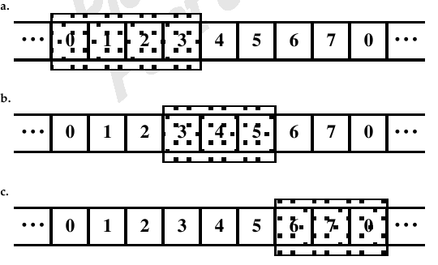
- No, because the field is of known fixed length. However, for simplicity, bit stuffing is used on this field.

  - When a flag is used as both an ending and starting flag (that is, one 8-bit pattern serves to mark the end of one frame and the beginning of the next), then a single-bit error in that flag alters the bit pattern so that the receiver does not recognize the flag. Accordingly, the received assumes that this is a single frame.
  - If a bit error somewhere in a frame between its two flags results in the pattern 01111110, then this octet is recognized as a flag that delimits the end of one frame and the start of the next frame.
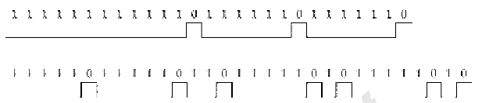
A problem with NRZ-L is its lack of synchronization capability: a long sequence of
1's or 0's yields a constant output voltage with no transitions. Bit-stuffing at least
eliminates the possibility of a long string of 1's.

